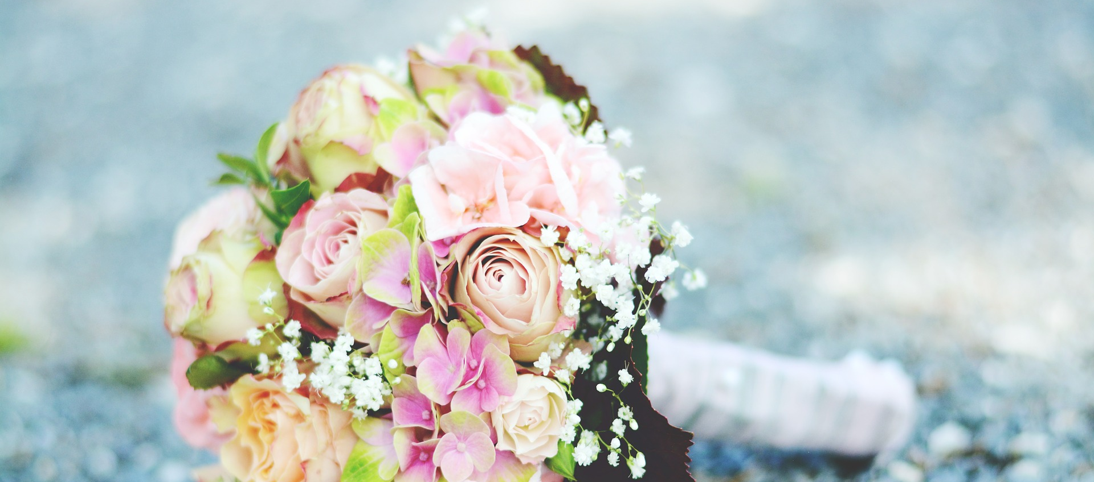

Wedding Booking Form
KAREN FARQUHAR
Caledonian Humanist Association
Aberdeen Celebrant
Registered Funeral Celebrant
Authorised to Conduct Legal Weddings in Scotland
Contact Information:
Telephone: 07950 792920
Email: karen.farquhar@cha.scot
www.aberdeencelebrant.co.uk
Legal Humanist Marriage Booking Form
Marriage Details
Date of Marriage |  | Time
Venue/Location
Full name of Celebrant | Karen Anne Elizabeth Farquhar
Designation | Humanist Celebrant, Caledonian Humanist Association
Address | 33 Woodend Crescent, Aberdeen AB15 6YP
Mobile number | 07950 792920
Email address | karen.farquhar@cha.scot
Full name of Bride/Groom/Partner 1
Date of Birth
Address
Home/Mobile number
Email address
Full name of Bride/Groom/Partner 2
Date of Birth
Address
(if different from above)
Home/Mobile number
Email address
PLEASE READ THE FOLLOWING NOTES CAREFULLY, AS THEY CONTAIN IMPORTANT LEGAL INFORMATION
The Responsibilities Of The Humanist Celebrant
- To provide a professional level of service at all times, ensuring that the ceremony is dignified, meaningful and personal within a broad Humanist framework.
- To ensure that the marriage is solemnised in accordance with the Marriage (Scotland) Act 1977 (including the required declarations) and in a location that is safe and dignified.
- To ensure that the marriage takes place on the date and at the place specified on the Marriage Schedule.
- To obtain the Marriage Schedule from the bride(s) and / or groom(s) before the ceremony can commence.
- To ensure that the Marriage Schedule is correctly signed in permanent black liquid ink, by both parties, two witnesses aged 16 or over and the Celebrant.
- If in the unlikely event of the Celebrant not being able to conduct the ceremony for some reason (e.g. illness), he/she will, where possible, arrange for another authorised Celebrant to conduct the ceremony instead (with the approval of the Registrar).
The Responsibilities Of The Couple
- The Registrar in the district where the marriage will take place requires Marriage Notice Forms (M10) to be submitted along with the requisite fee.
This must be done no sooner than 12 weeks and no later than 29 days before the ceremony. Therefore, you are advised to contact the Registrar as soon as possible once the three month date for the ceremony has passed.
- If either of you is not a British citizen, you should contact the Registrar immediately to check what documentation you will require in order to be married in Scotland.
- To inform the Registrar that the marriage will be solemnised by a Celebrant of the Caledonian Humanist Association, by completing Section F of the M10 forms.
- To collect the Marriage Schedule from the Registrar during the week prior to the marriage. One (or both) of the parties to the marriage must personally collect it.
- To deliver the Marriage Schedule to the Celebrant on or before the day of the
ceremony. Please note that the marriage cannot be legally conducted without the Marriage Schedule.
- To advise the Registrar in advance if there is any possibility of the marriage not taking place on the date or in the place specified (for example in the case of an outdoor ceremony being rained off).
- To take care of the signed Marriage Schedule and to return it to the Registrar within 3 days of the wedding taking place, so that the marriage can be registered. Please note that it can be returned to the Registrar by anyone.
- To pay the agreed fee and expenses for the humanist ceremony. A non-refundable £100 deposit is required to secure your booking. Deposit can be paid by cheque, made out to Karen Farquhar, or by BACS transfer to:
Sort Code: 87-34-36 Account: 85531760
If you are returning this form electronically, please accept these terms by placing an “X” in this box: ☐

Signatures
Celebrant |  | Date
Partner 1 |  | Date
Partner 2 |  | Date
Please sign above, return one copy of this document to the Celebrant and retain the other for your own reference. Thank you.
CEREMONY FEES AND EXPENSES FROM 01 JANUARY 2018
Legal Marriage Fee | £450.00
Non-legal wedding, affirmation ceremony, renewal of vows etc.. | £450.00
Wedding rehearsal | £100.00
Travel expenses (first 50 miles of travel are free) | 50p per mile
Other expenses (excess travel time, ferry charges, overnight accommodation etc..) | As negotiated with client
Please note that in addition to the above, statutory fees are also payable to the Registrar for the submission of Marriage Notices and for copies of the Marriage Certificate.
CHA Membership
- Free lifetime membership of the CHA for both parties is included with your ceremony. We promise we won’t bombard you with emails or pass your details on to any other organisation!
- Instead, your free life membership helps us increase our numbers and so be taken more seriously as an organisation. It also demonstrates:
- That you think for yourself, value creativity and imagination, and stand up for free speech, democracy, and human rights.
- That you are kind, honest, and responsible for your life, the lives of your family, and the future of the planet.
- That you respect the rights of others including their right to hold different beliefs from you.

So, have fun, and enjoy your life: it’s the only one you’ve got!

Your membership is important to us, however it is voluntary, and has no effect on your ceremony, so if either or both of you wish to be added to our membership list, please tick the appropriate box below:
Partner 1: ☐ Partner 2: ☐

